Hi there,

My kit contained the Zipabox & 5 Z Wave TKBHome metering socket & 2 motion sensors by Fibaro. I bought these to control some electric heaters. Below are details of the control panel. Any help you can offer would be greatly appreciated.

My aim with the above is to control my heating with the temperature details from the Fibaro motion sensor. Currently however it seems when the temperature falls outside the parameters the sockets are only activated by motion and not solely by the temperature.

Here is the main panel of my setup, my first question is should I have a device offline? The device offline is the IP backup.

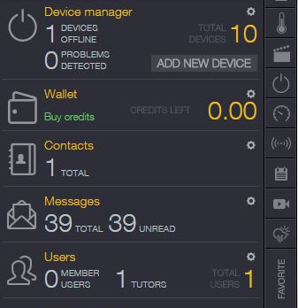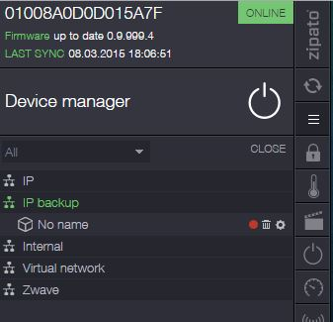

I have set my climate controls using the below details:
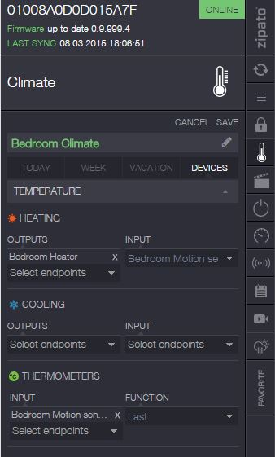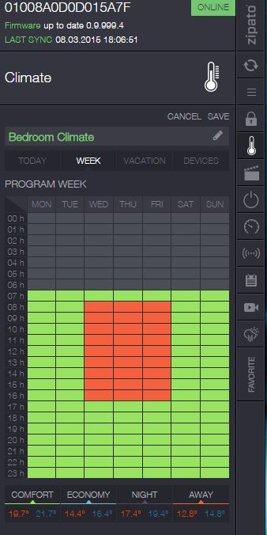

I am finding the following happening in each scenario:
Within temperatures and no motion = socket switched off (as I expect)
Within temperatures and motion = socket switched off (as I expect)
Outside of temperatures and no motion = socket switched off (not as expected)
Outside of temperatures and motion = socket turns on and switches off when motion stops.
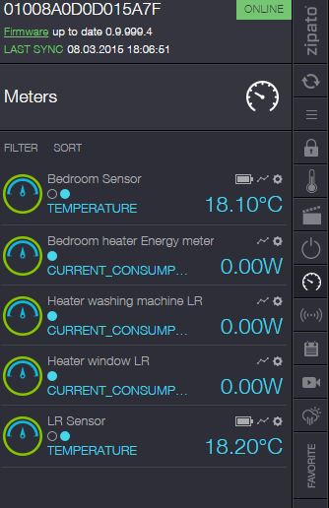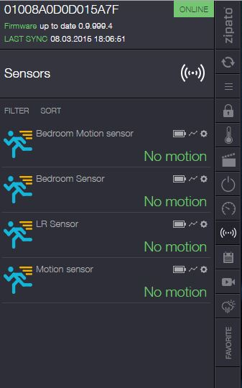

I have tried making the bedroom sensor visible on only temperature and switching off motion but I still get the same result. I have also tried removing the sensor completely and repairing but again behaviour is still the same.
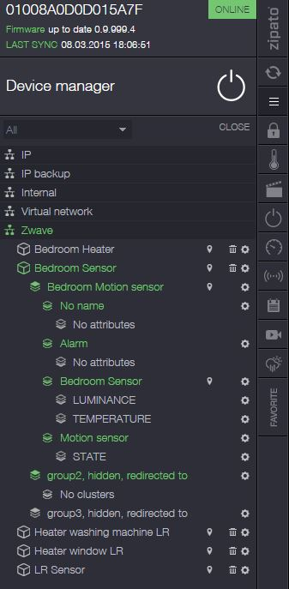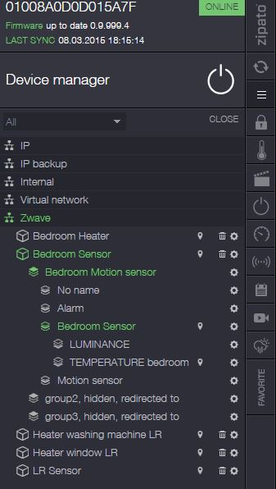
When outside temperature parameters and no movement I’d expect the socket to switch on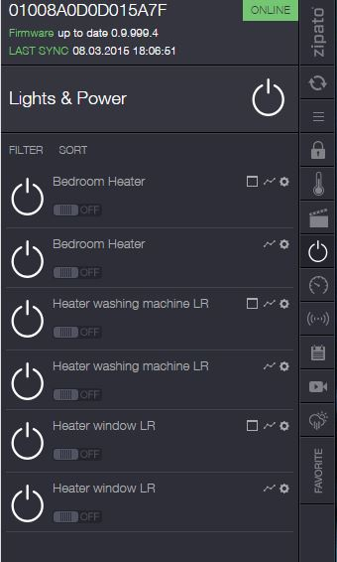

If you could provide details of how to set up the Fibaro motion sensor to default to temperature as being the main control for climate & heaters it would be a great help as I’m not sure why it’s only triggered by motion when outside parameters. I would like to retain the motion sensitivity however and not switch it off or anything as I’d like to use that feature for other devices in my home.

Many thanks
Haydn Huston

