Test 1

Need

Between 20 :00 and 20 :15, the light will be run

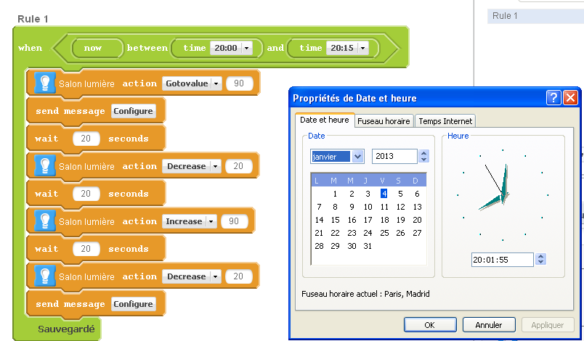

Result
Nothing run

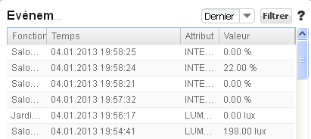

Test 2

Need
Each day a 20h15, the lamp should light

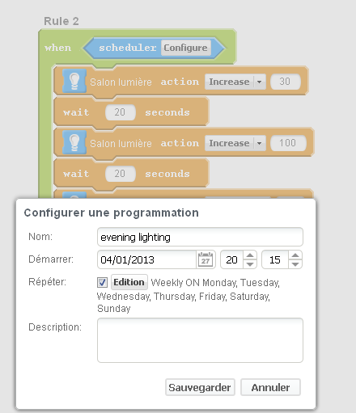

Result
few minutes after 20h15, nothing happens
