Below are instructions on how to flash the ZipaMicro SD card with the latest firmware and system image.

Download rufus from https://rufus.akeo.ie/downloads/rufus-2.18p.exe
Afterwards download the ZipaMicro image from https://s3-eu-west-1.amazonaws.com/update.zipato.com/zipamicro/142/zipaMicro-image.sdimg
Remove the Micro SD card from your ZipaMicro and plug it into your PC using a USB dongle or another card reader.
Use Rufus to flash it:
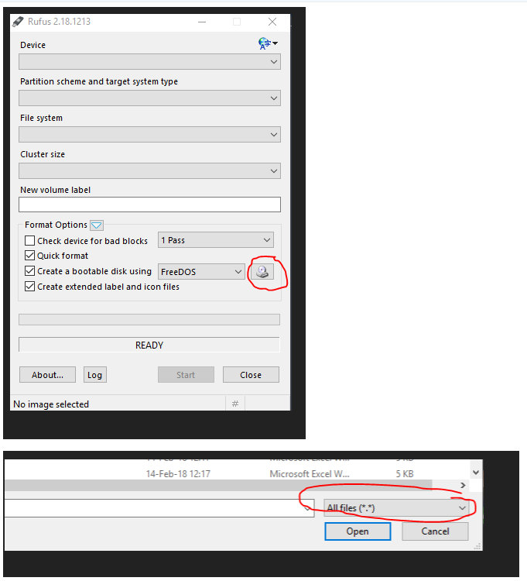

It should look like this before you press start:
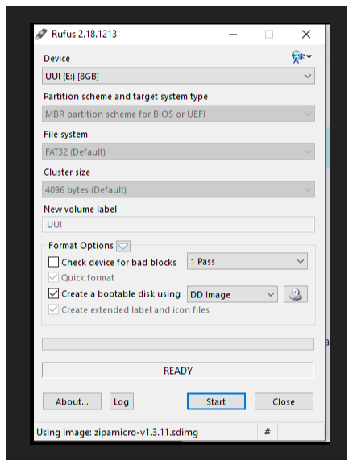
After the process has been finished, plug the Micro SD card back in the ZipaMicro.

